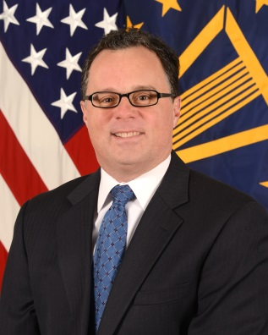

Mr. Robert A. Gold
Director, Engineering Enterprise
Office of the Deputy Assistant Secretary of Defense for Systems Engineering

Mr. Gold serves as Director of the Engineering Enterprise within the Office of the Deputy Assistant Secretary of Defense for Systems Engineering (DASD(SE)) under the Assistant Secretary of Defense for Research and Engineering (ASD(R&E)), Office of the Under Secretary of Defense for Acquisition, Technology, and Logistics (OUSD(AT&L)). Mr. Gold is a member of the Senior Executive Service. He is responsible for SE-related policy and guidance, specialty engineering, engineering tools and environments, hardware and software assurance, and defense standardization. He oversees workforce development for the defense acquisition engineering career fields Engineering (ENG) and Production, Quality and Manufacturing (PQM). His specialty engineering responsibilities include reliability and maintainability, system safety, manufacturing, human systems integration, and the Department of Defense (DoD) Value Engineering program.

Mr. Gold’s career spans more than 30 years with the Department of Defense, focusing on combat systems engineering, software, cyber, complex networking, and satellite acquisition. He holds a Master of Science degree in systems engineering from Virginia Tech, a Bachelor of Science degree in electrical engineering from Lehigh University, and a Public Management Certificate from Indiana University-Purdue University Indianapolis.

