National Defense Industrial Association
Integrated Program Management Division
NDIA IPMD Guide Update Process
In accordance with the requirements in the NDIA IPMD Charter, the following flowchart illustrates the IPMD guide update process that is described below.
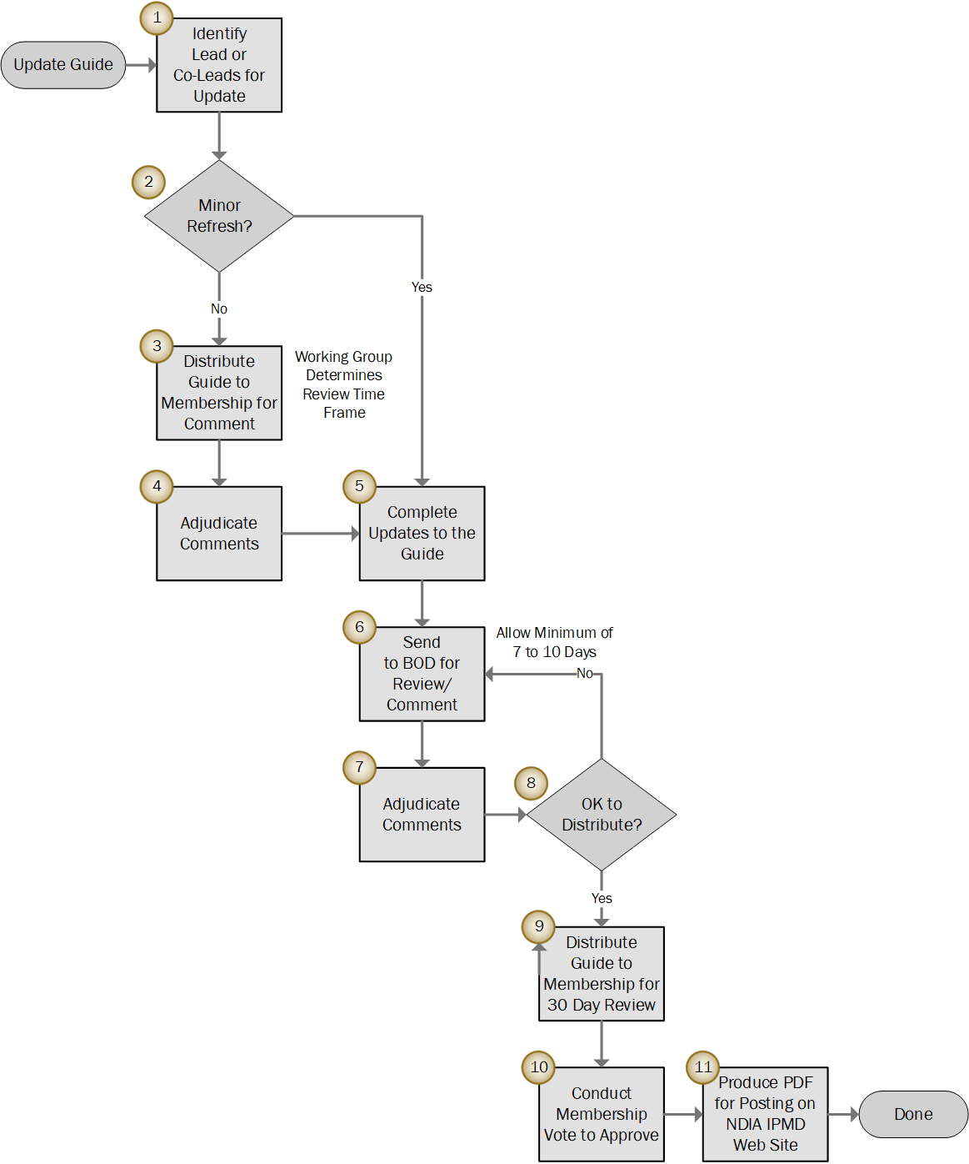

Introduction
The Guides Steering Group or Working Group Leads determine whether an existing guide is due for an update. Some working groups maintain specific guides such as the Agile and EVM Guide (Agile Working Group) and PASEG (Planning & Scheduling Working Group). The Guides Steering Group is responsible for maintaining other IPMD guides as well as the Master Definitions List for IPMD Guides.
Steps 1 and 2 assume an existing guide needs to be updated. For a new guide, the working group leads produce the content and begin at Step 3.

Step 1 – Identify Lead or Co-Leads for Update
Working with the board of directors (BOD), the Guides Steering Group identifies the lead or co-leads to do the update for any guide the Steering Group is responsible for maintaining.

Step 2 – Minor Refresh?
When applicable, the Guides Steering Group provides an initial assessment of the scope of the updates to the working group leads. There are two general categories of updates:
- Minor. The guide needs a general refresh to update government organization or regulation references, other document references, typo fixes, grammar fixes, or minor text edits. A small working group of 2 to 3 people is typically tasked with updating the guide. Minor updates do not require a membership comment cycle as part of the update. The process moves to Step 5.
- Major. The updates are more extensive and requires a membership comment cycle. It is up to the working group leads to determine how they would like to conduct the update. A temporary working group may be formed to review the guide, identify changes, and process the updates. A working cadence is established via web meetings and face to face working sessions such as at the IPMD meetings. The working group leads also establish a schedule for the update with applicable milestones and target completion date. They are also responsible for providing regular progress updates to the BOD.

Step 3 – Distribute Guide to Membership for Comment
The BOD assists the working group leads with the distribution to membership. The distribution typically includes the guide (MS Word or PDF format) and a comment spreadsheet. The working group leads determine the time frame for the review and comment cycle such as 30 or 45 days. In the distribution to membership, the leads provide any additional information such as the purpose and scope of the update. Include directions for using the comment spreadsheet. Also include contact information such as email addresses for the working group leads.

Step 4 – Adjudicate Comments
The working group adjudicates the comments from membership. Assuming a comment spreadsheet was provided, the typical policy is to reject comments that were not submitted using the comment spreadsheet. Comments that point out a perceived issue with the content that do not provide a recommendation or suggested edit are also typically rejected. For example, a comment such as “the language is unclear” will not be considered unless a recommended edit to the text is provided.

Step 5 – Complete Updates to the Guide
The working group completes their updates to the guide.

Step 6 – Send to BOD for Review/Comment
This step is required per the IPMD Charter. Once the working group completes their updates to the guide, the working group leads send it to the BOD for review and comment. Recommend sending a document with changes marked. Allow at least 7 to 10 calendar or working days for the BOD to review the document. For large documents such as the PASEG, allow extra time. If desired, the working group leads can include a comment spreadsheet with the document. Or, they can direct the BOD members to markup the document submitted for review.

Step 7 – Adjudicate Comments
The working group adjudicates the comments from the BOD.

Step 8 – OK to Distribute?
When the comments from the BOD are minor, the working group leads make the updates and provide an updated document to the BOD so they are aware of the updates. Mark the changes so it is easy to find the changes.
In instances where there are significant updates that need to be made, complete another review, comment, and adjudication cycle with the BOD.
Once the guide has successfully completed the BOD review and there are no further comments, the guide is ready to be distributed to membership.

Step 9 – Distribute Guide to Membership for 30 Day Review
This step is required per the IPMD Charter. The Charter stipulates membership must have at least 30 days to review a guide prior to voting to approve the guide for publication. The BOD assists the working group leads with the distribution to membership. For this step, the guide is distributed as a final edition PDF that is ready for publication.
The working group leads may provide recommended text to include with the distribution to membership along with their email addresses should membership have questions about the update. The working group leads may request time on the agenda for an upcoming IPMD meeting to present a summary of the comments received, adjudication results, and what has changed in the guide.
Any further comments received from membership from the 30-day review period should be minor such as correcting typos or grammar.

Step 10 – Conduct Membership Vote to Approve
As a reminder, only corporate NDIA members can vote to approve a guide. Each company has a designated voting representative, there is a single vote per company. Majority rules apply.
The voting may occur at a regularly scheduled IPMD meeting. The voting may be conducted by a show of hands or a paper ballot.
As an alternative, voting may occur using an electronic ballot that is sent to the designated voting representative. The typical time frame for voting representatives to submit their electronic ballot is 10 days. When there is no reply to the ballot request, approval is assumed.

Step 11 – Produce PDF for Posting on the NDIA IPMD Web Site
Once membership has approved the guide, the Guides Steering Group provides the final PDF document to the NDIA for posting on the IPMD web site. When the new document is posted, the revision number and date reference are updated. Often the description for the guide is also updated.

Example Base Text for Distribution Emails
Major Update to an Existing Guide Requiring Membership Comments
Email Subject: NDIA IPMD - [Named Guide and Revision Number] – Comments due by [date]
NDIA IPMD Members:
Attached is the [named guide and revision number] for review along with a comment spreadsheet. Please follow the instructions in the spreadsheet for providing comments to [named] working group.
[Insert sentence or short paragraph describing the purpose and scope of the update required.]
You have a [30] days to review the guide and provide comments. Please email your comment spreadsheet by [date], to [named person and email address] and copy [Vice-Chair’s name and email address]. The comments will be adjudicated [by named working group] and a final guide will be published for a subsequent vote.
Guide is Ready for Membership 30 Day Review Period
Email Subject: NDIA IPMD - [Named Guide and Revision Number] – 30 Day Review Period
NDIA IPMD Members:
As part of the regular three-year cycle to review and update the NDIA IPMD Guides, the [date and revision number] of the [named] Guide has been reviewed and updated, and is attached for your review. [Insert sentence or short paragraph summarizing the updates – the updates may have been presented at a previous IPMD meeting].
In accordance with the IPMD Charter, this revision has been approved by the IPMD Board of Directors for membership review in preparation for voting to approve the guide.
If you have any questions about the [named guide] send an email to [named person and email address] and copy [Vice-Chair’s name and email address] by [date].
[If voting by electronic ballot] Unless there are any material concerns, a subsequent electronic ballot will be sent to the IPMD corporate voting members after the 30-day review period for voting. [Else will be voted upon at the next IPMD meeting.]
For an Electronic Ballot to Designated Corporate Voting Representatives
Email Subject: NDIA IPMD - Vote to Approve the NDIA IPMD [Named Guide and Revision Number]
NDIA IPMD Voting Members:
[Named Guide and Revision Number] has been completed and was distributed to the IPMD membership for the required 30-day review on [Date]. [Add reminder text about the update to the guide. The updates to the guide may have also been presented at a recent IPMD meeting.]
For questions about the [Named Document] content, please contact [named POC with email address].
Reply to this email stating that you “Approve” or “Disapprove” of the [named guide].

